

**.Net Lab Manual**

**Er.No: 170473107005**

**Submitted by,**

**Jemish Harsora**

**VVP CE SEM-6**

**YEAR -2019**



Contents

AIM : Introduction to c# 1

AIM: Inheritance 7

Program 1 7

Program 2 9

Program 3 10

Program 4 11

AIM: Method & constructor overloading 14

Program 1 14

Program 2 17

AIM:Reflection 19

Program:1 19

AIM:File Handling 22

Program: 1 22

Program 2: 23

Program 3: 25

AIM:Windows Form Application 27

Program: 27

AIM:ASP.NET VALIDATION CONTROL 30

Program 30

**Aim:**Introduction To Master Pages 33

# AIM : Introduction to c#

**Variables:**

**Initialization**

**Scope**

**Constant**

**Predefined Data Types**

**Value Types**

**Reference TYpes**

**Flow Control**

**Conditional Statements(if, switch)**

**Loop(for, while, dowhile, foreach)**

**Jump(goto, break, continue, return)**

**Eumerations**

**Passing Arguments**

using System;

using System.Collections.Generic;

using System.Linq;

using System.Text;

using System.Threading.Tasks;

namespace aim

{

class Program

{

static int newint=100;

public enum TimeOfDay

{

Morning = 0,

Afternoon = 1,

Evening = 2

}

public static void Main(string[] args)

{

Console.WriteLine("\n integer types");

sbyte sb = 10;

short s = 33;

int i = 10;

long l = 33L;

byte b = 22;

ushort us = 33;

uint ul = 33u;

ulong ulo = 33ul;

Console.WriteLine("{0},{1},{2},{3},{4},{5},{6},{7}", sb, s, i, l, b, us, ul, ulo);

float f = 1.122345656767f;

double d = 12.1234455657878797;

Console.Write("\nFloat and Double:\n");

Console.WriteLine("{0} and \n{1}", f, d);

decimal dec=111.666666666666666666666M;

Console.WriteLine("decimal:\n{0} ",dec);

Console.WriteLine("\nBoolean:");

bool boolean =true;

Console.WriteLine("Status: " + boolean);

// Console.ReadLine();

char character ='d';

Console.WriteLine(character);

character = '\0';

Console.WriteLine("Now null: " + character);

object o1 = "Hi, I am ALICE";

object o2 = 15.3454365;

string strObj = o1 as string;

Console.WriteLine(strObj);

Console.WriteLine(o1.GetHashCode() + " " + o1.GetType());

Console.WriteLine(o2.GetHashCode() + " " + o2.GetType());

Console.WriteLine(o1.Equals(o2));

string s1, s2;

s1 = "this is string";

s2 = s1;

Console.WriteLine("S1 is: {0} and s2 is {1}", s1, s2);

s2 = "other string";

Console.WriteLine("S1 is: {0} and s2 is {1}", s1, s2);

s1 = "c:C:\\Users\\Dell\\source\\repos\\aim";

Console.WriteLine(s1);

s1 = @"c:C:\Users\Dell\source\repos\aim\aim";

Console.WriteLine(s1);

s1 = @"We can also write

like this";

Console.WriteLine(s1);

bool isZero;

Console.WriteLine("\nFlow Control: (if)\ni is " + i);

if (i == 10)

{

isZero = true;

Console.WriteLine("i is Zero {0}",isZero);

}

else

{

isZero = false;

Console.WriteLine("i is Non - zero");

}

int integerA = 1;

Console.WriteLine("\nSwitch:");

switch (integerA)

{

case 1:

Console.WriteLine("integerA = 1");

break;

case 2:

Console.WriteLine("integerA = 2");

//goto case 3;

break;

case 3:

Console.WriteLine("integerA = 3");

break;

default:

Console.WriteLine("integerA is not 1, 2, or 3");

break;}

WriteGreeting(TimeOfDay.Morning);

Console.WriteLine("Argument is: {0}",args[1]);

void WriteGreeting(TimeOfDay timeOfDay)

{

switch (timeOfDay)

{

case TimeOfDay.Morning:

Console.WriteLine("Good morning!");

break;

case TimeOfDay.Afternoon:

Console.WriteLine("Good afternoon!");

break;

case TimeOfDay.Evening:

Console.WriteLine("Good evening!");

break;

default:

Console.WriteLine("Hello!");

break;

}}

Console.WriteLine("Scope of Variables.\n1:");

int newint=0;

int j;

for (/*int*/ j = 0; j < 2; j++) //removing comment from for loop will raise error

{

//int j;

//uncomment above line to error "A local variable named 'j' cannot be declared in this

//scope because it would give a different meaning to 'j', which is already

//used in a 'parent or current' scope to denote something else"

Console.Write("{0} {1}\n", newint, Program.newint);

}

Console.WriteLine("2:");

for (int k = 0; k < 3; k++)

{

Console.Write("{0} ", k);

}//Scope of k ends here

Console.Write("\n");

//Console.Write(k);

//uncomment above line to see error "The name 'k' does not exist in the current context"

for (int k = 3; k > 0; k--)

{

Console.Write("{0} ", k);

}//scope of k ends here again

Console.WriteLine("Constants");

const int valConst = 100; // This value cannot be changed.

Console.WriteLine("{0} is constant value", valConst);

//valConst = 45;

//uncomment above line to see error "The left-hand side of an assignment must be a variable, property or indexer"

//const only allow constant variables into the expression

const int valConst2 = valConst + 9 /* + j*/;

//remove comments from the above line to see error "The expression being assigned to 'valConst2' must be constant"

Console.WriteLine("Another Constant: {0}", valConst2);

Console.WriteLine("\nPredefined Data Types\n\nValue Types and Reference Types");

//Value Types

int vali = 2, valj = vali;

Console.WriteLine("vali is: {0} and valj is: {1}", vali, valj);

valj = 90;

Console.WriteLine("vali is: {0} and valj is: {1}", vali, valj);

//Referece Types

Vector x, y;

x = new Vector();

x.value = 3;

y = x;

Console.WriteLine("x is: {0} and y is:{1}", x.value, y.value);

y.value = 234;

Console.WriteLine("x is: {0} and y is:{1}", x.value, y.value);

//If a variable is a reference, it is possible to indicate that it does not refer to any object by setting its value to null:

y = null;

//Console.Write("Value for y is: " + y.value);

//uncomment above line to see runtime exception "System.NullReferenceException: Object reference not set to an instance of an object."

//CTS

}

public class Vector

{

public int value;

}

}

}

**OUTPUT**

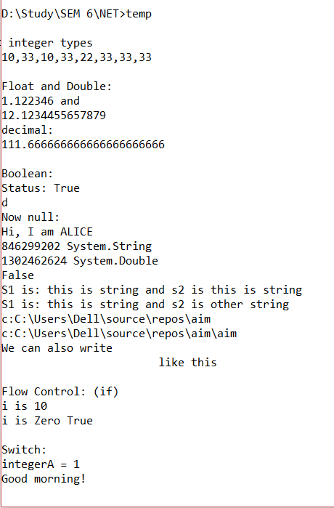

# 

# AIM: Inheritance

## Program 1

**Perform following programs in c#.**

**1. Write console based program in code behind language VB or C# to print following pattern.**

**@ @ @ @ @**

**@ @ @ @**

**@ @ @**

**@ @**

**@**

using System;

using System.Collections.Generic;

using System.Linq;

using System.Text;

using System.Threading.Tasks;

namespace pattern1

{

class Program

{

static void Main(string[] args)

{

for(int i=5;i>0;i--)

{

for (int j = i; j > 0; j--)

{

Console.Write("@");

}

Console.WriteLine(" ");

}

Console.ReadKey();

}

}

}

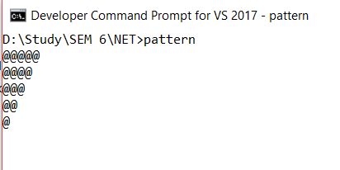**OUTPUT**

## Program 2

**Write console based program in code behind language VB or C# to print following pattern.**

1

1 2

1 2 3

1 2 3 4

using System;

using System.Collections.Generic;

using System.Linq;

using System.Text;

using System.Threading.Tasks;

namespace pattern2

{

class Program

{

static void Main(string[] args)

{

for(int i=1;i<=5;i++)

{

for(int j=i;j>0;j--)

{

Console.Write("{0}",i);

}

Console.WriteLine("");

}

Console.ReadKey();

}

}}

**OUTPUT**

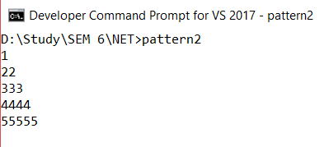

## Program 3

**Write C# code to prompt a user to input his/her name and country name and then the output will be shown as an example below:**

**Hello Ram from country India**

using System;

using System.Collections.Generic;

using System.Linq;

using System.Text;

using System.Threading.Tasks;

namespace country

{

class Program

{

static void Main(string[] args)

{

string name;

string country;

Console.WriteLine("enter your name:");

name=Console.ReadLine();

Console.WriteLine("enter your country:");

country = Console.ReadLine();

Console.WriteLine("hello {0} from country {1}",name,country);

Console.ReadKey();

}

}

}

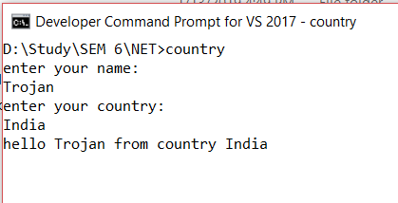**OUTPUT**

## Program 4

**What is inheritance? Create C# console application to define Car class and derive Maruti and Mahindra from it to demonstrate inheritance.**

using System;

using System.Collections.Generic;

using System.Linq;

using System.Text;

using System.Threading.Tasks;

namespace practical2._3

{

class car

{

public void Method1()

{

Console.WriteLine("this is the method of car class");

}

}

class maruti:car

{

public void method2()

{

Console.WriteLine("this is the method of maruti");

Console.ReadKey();

}

}

class mahindra:car

{

public void method3()

{

Console.WriteLine("this is the method of mahindra");

}

}

class Program

{

static void Main(string[] args)

{

mahindra m = new mahindra();

maruti m1 = new maruti();

m.Method1();

m1.Method1();

Console.ReadKey();

}

}

}

**OUTPUT**

# 

# AIM: Method & constructor overloading

## Program 1

**Write a c# program to add two integers, two vectors and two metric using method overloading.**

using System;

using System.Collections.Generic;

using System.Linq;

using System.Text;

namespace p2

{

public class P3_1

{

public int add(int a, int b) {

return a + b;

}

public static Vector add(Vector v1,Vector v2) { Vector v= new Vector();

v.a = v1.a + v2.a; v.b = v1.b + v2.b;

return v;

}

public static int[,] add(int[,] a, int[,] b) {

int[,] s = new int[2, 2];

for (int i = 0; i < 2; i++) {

for (int j = 0; j < 2; j++) {

s[i, j] = a[i, j] + b[i, j];

}

}

return s;

}

public static void Main(String[] ar) {

int n,n1, n2;

Vector v = new Vector();

Console.WriteLine("Enter Number 1:");

n1 = Convert.ToInt32(Console.ReadLine());

Console.WriteLine("Enter Number 2:");

n2 = Convert.ToInt32(Console.ReadLine());

n = n1 + n2;

Console.WriteLine("Addition of Number:{0}", n);

Console.WriteLine("Enter Vector 1:");

n1 = Convert.ToInt32(Console.ReadLine()); n2 = Convert.ToInt32(Console.ReadLine());

Vector v1 = new Vector(n1,n2);

Console.WriteLine("Enter Vector 2:");

n1 =Convert.ToInt32(Console.ReadLine()); n2 = Convert.ToInt32(Console.ReadLine()); Vector v2 = new Vector(n1,n2);

v = add(v1, v2);

Console.WriteLine("Addition of vector: <{0}, {1}>",v.a,v.b);

int[,] a = new int[,] { { 1, 2 }, { 3, 4 } };

int[,] b = new int[,] { { 5, 6 }, { 7, 8 } };

int[,] c = add(a, b); Console.WriteLine("Addition of two matrics:");

for (int z = 0; z < 2; z++) {

for (int m = 0; m < 2; m++) {

Console.WriteLine("Addition: "+ c[z, m]);

}

}

Console.ReadKey();

}

}

public class Vector {

public int a, b;

public Vector() { }

public Vector(int a, int b)

{

this.a = a;

this.b = b;

}

}

}

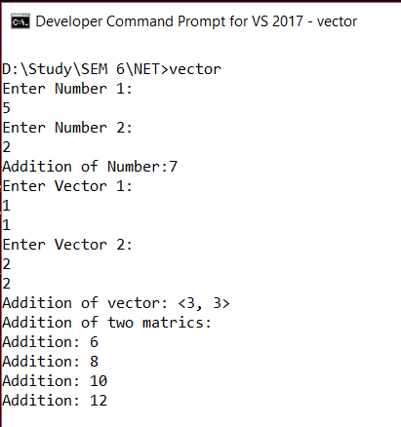**OUTPUT**

## Program 2

**Write a c# program that create student object. Overload constructor to create new instant with following details.**

**1. Name**

**2. Name, Enrollment**

**3. Name, Enrollment, Branch**

using System;

using System.Collections.Generic;

using System.Linq;

using System.Text;

using System.Threading.Tasks;

using System.Reflection;

namespace p3a1

{

class Program

{

public int ID { get; set; }

public string Name { get; set; }

String name, branch;

int enrol;

public Program(String name)

{

this.name = name;

Console.WriteLine("constructor 1:" + name);

}

public Program(String name, int enrol)

{

this.name = name;

this.enrol = enrol;

Console.WriteLine("constructor 2:" + name + " " + enrol);

}

public Program(String name, int enrol, String branch)

{

this.name = name;

this.enrol = enrol;

this.branch = branch;

Console.WriteLine("constructor 3:" + name + " " + enrol + " " + branch);

}

static void Main(string[] args)

{

Program p1 = new Program("Dhyey");

Program p2 = new Program("ABC", 60);

Program p3 = new Program("ABC ", 60, "CE");

Console.ReadLine();

}

}

}

# AIM:Reflection

## Program:1

**Create a c# program to find Methods, Properties and Constructors from class of running program.(Use Class from previous practical)**

using System;

using System.Collections.Generic; using System.Linq;

using System.Text;

using System.Reflection;

namespace p2

{

class Reflection

{

static void Main()

{

Type T = Type.GetType("p2.Customer");

MethodInfo[] methods = T.GetMethods();

foreach (MethodInfo method in methods)

{

Console.WriteLine(method.ReturnType + " " + method.Name);

}

PropertyInfo[] properties = T.GetProperties();

Console.WriteLine("\nProperties");

foreach (PropertyInfo property in properties)

{

Console.WriteLine(property.PropertyType + " " + property.Name);

}

Console.WriteLine("\nConstructors");

ConstructorInfo[] constructors = T.GetConstructors();

foreach (ConstructorInfoconstructor in constructors) {

Console.WriteLine(constructor.ToString());

}

}

}

class Customer

{

public int ID { get; set; }

public string Name { get; set; }

public Customer(int ID, string Name)

{

this.ID = ID; this.Name = Name;

}

**REFLECTION:**

public Customer()

{

this.ID = -1;

this.Name = string.Empty;

}

public void printID()

{

Console.WriteLine("ID is: {0}", this.ID);

}

public void printName()

{

Console.WriteLine("Name is: {0}", this.Name); }

}

}

**Output:**

E: \Sem-6\VS\p2\p2>Reflection.exe

System.Int32 get_ID

System. Void set_ID

System.String get_Name

System.Void set_Name

System.Void printID

System.Void printName

System.String ToString

System.Boolean Equals

System.Int32 GetHashCode

System.Type GetType

Properties

System.Int32 ID

System.String Name

Constructors

Void .ctor(Int32, System.String)

Void .ctor()

# AIM:File Handling

## Program: 1

**Write a C# program to copy data from one file to another using StreamReader and StreamWriter class.**

using System;

using System.Collections.Generic; using System.Linq; using System.Text;

using System.IO;

namespace p2

{

class P4_1

{

public static void Main()

{

string f1 = @"f1.txt"; string f2 = @"f2.txt";

using (StreamReader reader = new StreamReader(f1)) using (StreamWriter writer = new StreamWriter(f2))

writer.Write(reader.ReadToEnd());

}

}

}

**Output:**

F1.txt: Hello World…

F2.txt: Hello World…

Program 2:

**Write a C# Program to Read Lines from a File until the End of File is Reached.**

using System;

using System.Collections.Generic; using System.Linq; using System.Text;

using System.IO;

namespace p2

{

public class CopyFile

{

public void copyFile(string f1, string f2)

{

using (StreamReader reader = new StreamReader(f1)) using (StreamWriter writer = new StreamWriter(f2))

{

string line = null;

while ((line = reader.ReadLine()) != null)

writer.WriteLine(line);

}

}

}

public class mmain{

public static void Main(){

CopyFile cp = new CopyFile();

string f1 = @"E:\Sem-6\VS\p2\p2\f1.txt"; string f2 = @"E:\Sem-6\VS\p2\p2\f2.txt"; cp.copyFile(f1,f2);

}

}

}

**Output:**

F1.txt: Hello World.....

hii

how are you

???

F2.txt: Hello World.....

hii

how are you

???

Program 3:

**Write a C# Program to List Files in a Directory.**

using System;

using System.Collections.Generic; using System.Linq; using System.Text;

using System.IO;

namespace p2

{

class ListFile

{

public static void Main() {

string[] Directories = Directory.GetDirectories(@"E:\Sem-6\VS");

foreach (string dir in Directories)

Console.WriteLine(dir);

string[] files = Directory.GetFiles(@"E:\Sem-6\VS");

foreach (string file in files)

Console.WriteLine(file);

Console.ReadKey();

}

}

}

**Output:**

E:\Sem-6\VS\p2\p2>P4.3.exe

E:\Sem-6\VS\P1-master

E: \Sem-6\VS\p2

E:\Sem-6\VS\Assignment.docx

E: \Sem-6\VS\C# word.txt

E:\Sem-6\VS\Doc1.docx

E: \Sem-6\VS\P1-master.zip

E: \Sem-6\VS\p1.cs

E:\Sem-6\VS\p1.exe

E: \Sem-6\VS\VS.docx E:\Sem-6\VS\~$VS.docx

# AIM:Windows Form Application

Program:

**Create Windows Form Application for Student Registration and store student Details in Database.**

**Form.cs:**

using System;

using System.Collections.Generic; using System.ComponentModel; using System.Data;

using System.Drawing; using System.Linq;

using System.Text;

using System.Windows.Forms;

using System.Data.SqlClient; using System.IO;

namespace StudentForm

{

public partial class Form1 : Form

{

string imgPath;

public Form1()

{

InitializeComponent();

}

private void btnsave_Click(object sender, EventArgs e)

{

string gen = null;

string subject = null;

if (genMale.Checked == true) {

gen = "m";

}

if (genFemale.Checked == true) { gen = "f";

}

if (ck1.Checked == true) {

subject = subject + " s1";

}

if (ck2.Checked == true) {

subject = subject + " s2";

}

string source = @"Data Source=Deep -Pambhar\SQLExpress;

Initial Catalog=DemoDb;Integrated Security=True;Pooling=False";

string insert = "insert into tblstudent

(fname,lname,gender,subject,imgStudent) values ('" + txtfname.Text + "','"

+ txtlname.Text + "','" + gen + "','" + subject + "','" + (imgPath

== null ? "" : imgPath) + "')";

SqlCommand cmd = new SqlCommand(insert,conn);

conn.Open();

int i = cmd.ExecuteNonQuery();

conn.Close();

Console.WriteLine("Success....");

}

private void Form1_Load(object sender, EventArgs e)

{

}

private void btnimg_Click(object sender, EventArgs e)

{

openFileDialog1.Filter = "Jpg|*.jpg";

if (openFileDialog1.ShowDialog() == DialogResult.OK)

{

imgPath = openFileDialog1.SafeFileName;

pictureBox.Image = Image.FromFile(openFileDialog1.FileName);

//MessageBox.Show(imgPath);

}

}

}

}

**Program.cs:**

using System;

using System.Collections.Generic; using System.Linq;

using System.Windows.Forms;

namespace StudentForm

{

static class Program {

/// <summary>

/// The main entry point for the application.

/// </summary>

[STAThread]

static void Main()

{

Application.EnableVisualStyles();

Application.SetCompatibleTextRenderingDefault(false); Application.Run(new Form1());

}

}

}

**Output:**

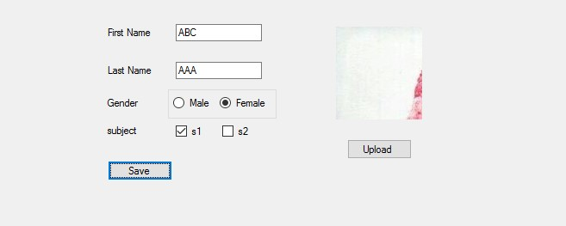

# AIM:ASP.NET VALIDATION CONTROL

Program: ASP.NET Validation Control

* RequiredFieldValidator
* CompareValidator
* RegularExpressionValidator
* CustomValidator
* RangeValidator
* ValidationSummary

<%@ Page Title="Home Page" Language="C#" AutoEventWireup="true"

CodeBehind="Default.aspx.cs" Inherits="WebApplication2._Default" %>

< form id="form1" runat="server">

<div>

<table>

<tr>

<td>

<asp:Label runat="server" Text="Name"></asp:Label>

&nbsp;&nbsp;&nbsp;&nbsp;&nbsp;&nbsp;&nbsp;&nbsp;&nbsp;&nbsp;&nbsp

;&nbsp;&nbsp;&nbsp;&nbsp;&nbsp;&nbsp;&nbsp;&nbsp;&nbsp;&nbsp;&nbs p;

<asp:TextBox ID="txtname" runat="server" ></asp:TextBox>

<asp:RequiredFieldValidator ID="RequiredFieldValidator1"

runat="server"

ControlToValidate="txtname"

ErrorMessage="RequiredFieldValidator"></asp:RequiredFieldValidat or>

<br />

</td>

</tr>

<tr>

<td>

<asp:Label ID="Email" runat="server" Text="Email"></asp:Label>

&nbsp;&nbsp;&nbsp;&nbsp;&nbsp;&nbsp;&nbsp;&nbsp;&nbsp;&nbsp;&nbsp

;&nbsp;&nbsp;&nbsp;&nbsp;&nbsp;&nbsp;&nbsp;&nbsp;&nbsp;&nbsp;&nbs p;&nbsp;

<asp:TextBox ID="txtemail" runat="server"></asp:TextBox>

<asp:RegularExpressionValidator ID="RegularExpressionValidator1" runat="server"

ErrorMessage="RegularExpressionValidator"

ValidationExpression="\w+([-+.']\w+)*@\w+([-.]\w+)*\.\w+([-

.]\w+)*"

ControlToValidate="txtemail"></asp:RegularExpressionValidator>

<br />

</td>

</tr>

<tr>

<td>

<asp:Label ID="Label3" runat="server"

Text="Password"></asp:Label>

&nbsp;&nbsp;&nbsp;&nbsp;&nbsp;&nbsp;&nbsp;&nbsp;&nbsp;&nbsp;&nbsp ;&nbsp;&nbsp;&nbsp;&nbsp;&nbsp;

<asp:TextBox ID="txtpass" runat="server"

TextMode="Password"></asp:TextBox>

<br />

</td>

</tr>

<tr>

<td>

<asp:Label ID="Label4" runat="server" Text="Confirm Password"></asp:Label>

&nbsp;&nbsp;&nbsp;

<asp:TextBox ID="txtcpass" runat="server"

TextMode="Password"></asp:TextBox>

<asp:CompareValidator ID="CompareValidator1" runat="server"

ControlToCompare="txtcpass" ControlToValidate="txtpass"

ErrorMessage="CompareValidator"></asp:CompareValidator>

<br />

</td>

</tr>

<tr>

<td>

<asp:Label ID="Label5" runat="server" Text="Sem"></asp:Label>

<asp:TextBox ID="txtsem" runat="server"></asp:TextBox>

<asp:RangeValidator ID="RangeValidator1" runat="server"

ControlToValidate="txtsem" ErrorMessage="RangeValidator"

MaximumValue="8"

MinimumValue="1"></asp:RangeValidator>

<br />

<asp:ValidationSummary ID="ValidationSummary1" runat="server"

/> </td>

</tr>

<tr>

<td>

<asp:Button ID="Button1" runat="server" Text="Save"/> </td>

</tr>

</table>

</div>

</form>

**Output:**

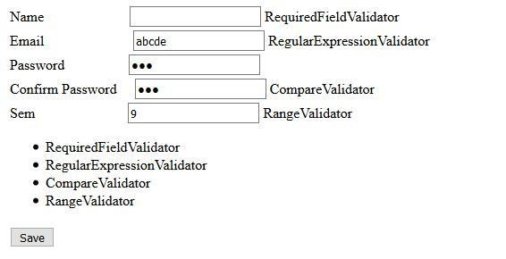

# **Aim:**Introduction To Master Pages

**Site1.Master:**

<%@ Master Language="C#" AutoEventWireup="true" CodeBehind="Site1.master.cs"

Inherits="WebApplication1.Site1" %>

<!DOCTYPE html PUBLIC "-//W3C//DTD XHTML 1.0 Transitional//EN"

"http://www.w3.org/TR/xhtml1/DTD/xhtml1-transitional.dtd"> <html xmlns="http://www.w3.org/1999/xhtml"> <head run at="server">

<title></title>

<asp:ContentPlaceHolder ID="head" runat="server"> </asp:ContentPlaceHolder> <style type="text/css">

.style1 { width: 97px;

height: 141px;

}

.style2

{ width: 97px;

height: 105px;

}

.style3

{

width: 97px;

height: 99px;

}

.style4

{ width: 9px;

}

</style>

< /head>

<body>

<form id="form1" runat="server">

<table height="50%" width="50%">

<tr>

<td class="style2" colspan="2">

<asp:Label ID="lblheader" runat="server"

Text="Header"></asp:Label> </td>

</tr>

<tr>

<td class="style4">

<asp:Button ID="btnsearch" runat="server" Text="search" />

<asp:TextBox ID="txtsearch" Runat="server"></asp:TextBox> </td>

<td class="style3">

<asp:ContentPlaceHolder ID="ContentPlaceHolder1"

runat="server"> content page

</asp:ContentPlaceHolder>

</td>

</tr>

<tr>

<td class="style1" colspan="2">

<asp:Label ID="lblfooter" runat="server"

Text="Footer"></asp:Label> </td>

</tr>

</table>

</form>

< /body>

</html>

**Site1.Master.cs:**

using System;

using System.Collections.Generic; using System.Linq; using System.Web; using System.Web.UI; using System.Web.UI.WebControls;

namespace WebApplication1

{

public partial class Site1 : System.Web.UI.MasterPage {

protected void Page_Load(object sender, EventArgs e)

{

}

public Label LblHeader {

get {

return lblheader;

}

} public Button BtnSearch { get {

return btnsearch;

}

} public TextBox TxtSearch { get {

return txtsearch;

}

}

}

}

**WebForm1.aspx:**

<%@ Page Title="" Language="C#" MasterPageFile="~/Site1.Master"

AutoEventWireup="true" CodeBehind="WebForm1.aspx.cs"

Inherits="WebApplication1.WebForm1" %>

<asp:Content ID="Content1" ContentPlaceHolderID="ContentPlaceHolder1" runat="server">

<asp:TextBox ID="txtname" runat="server" ></asp:TextBox>

<asp:Button ID="Button1" runat="server" Text="Set Header" onclick="Button1_Click" />

</asp:Content>

**WebForm1.aspx.cs:**

using System;

using System.Collections.Generic; using System.Linq; using System.Web; using System.Web.UI;

using System.Web.UI.WebControls;

namespace WebApplication1

{

public partial class WebForm1 : System.Web.UI.Page {

protected void Page_Load(object sender, EventArgs e)

{

}

protected void Button1_Click(object sender, EventArgs e)

{

((Site1)Master).LblHeader.Text = txtname.Text;

}

}

}

**WebForm2.aspx:**

<%@ Page Title="" Language="C#" MasterPageFile="~/Site1.Master"

AutoEventWireup="true" CodeBehind="WebForm2.aspx.cs"

Inherits="WebApplication1.WebForm2" %>

<asp:Content ID="Content2" ContentPlaceHolderID="ContentPlaceHolder1" runat="server"> <asp:GridView ID="grdstudent" runat="server">

< /asp:GridView>

</asp:Content>

**WebForm2.aspx.cs:**

using System;

using System.Collections.Generic; using System.Linq; using System.Web; usin g System.Web.UI; using System.Web.UI.WebControls; using System.Data.SqlClient; namespace WebApplication1

{

public partial class WebForm2 : System.Web.UI.Page {

protected void Page_Init(object sender, EventArgs e)

{

((Site1)Master).BtnSearch.Click += new EventHandler(BtnSearch_Click); }

void BtnSearch_Click(object sender, EventArgs e)

{ getData();

}

protected void Page_Load(object sender, EventArgs e)

{}

void getData() {

string s= ((Site1)Master).TxtSearch.Text;

Console.WriteLine(s);

string source = @"Data Source=Deep -Pambhar\SQLExpress;Initial Catalog=DemoDb;Integrated Security=True;Pooling=False"; string select = "select * from tblstudent where fname like '%"+

((Site1)Master).TxtSearch.Text + "%'";

SqlConnection con = new

SqlConnection(source); SqlCommand cmd = new SqlCommand(select, con); con.Open();

SqlDataReader rdr = cmd.ExecuteReader(); grdstudent.DataSource = rdr;

grdstudent.DataBind();

con.Close();

}

}

}

**Output:**

